**Observation 34-dynamic sql in ddl**

Create table:

CREATE TABLE employee_reports (

report_id NUMBER GENERATED BY DEFAULT AS IDENTITY,

last_name VARCHAR2(100),

salary NUMBER,

department_id NUMBER,

report_date DATE

);

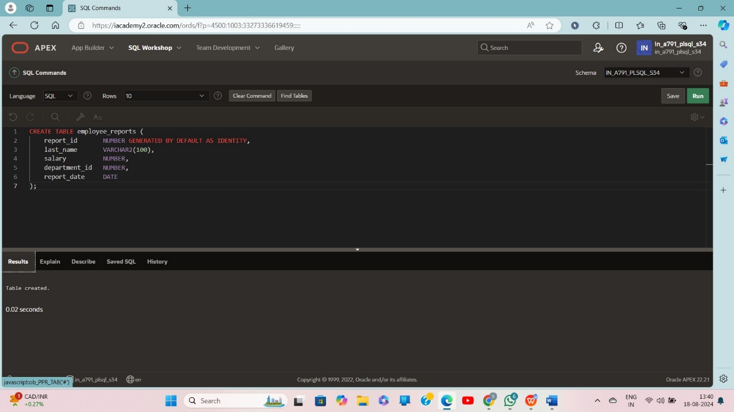

Create package:

CREATE OR REPLACE PROCEDURE drop_any_table(p_table_name VARCHAR2) IS

v_dynamic_stmt VARCHAR2(200);

BEGIN

v_dynamic_stmt := 'DROP TABLE ' || p_table_name;

EXECUTE IMMEDIATE v_dynamic_stmt;

DBMS_OUTPUT.PUT_LINE('Table ' || p_table_name || ' dropped successfully.');

EXCEPTION

WHEN OTHERS THEN

DBMS_OUTPUT.PUT_LINE('Error dropping table ' || p_table_name || ': ' || SQLERRM);

END;

/

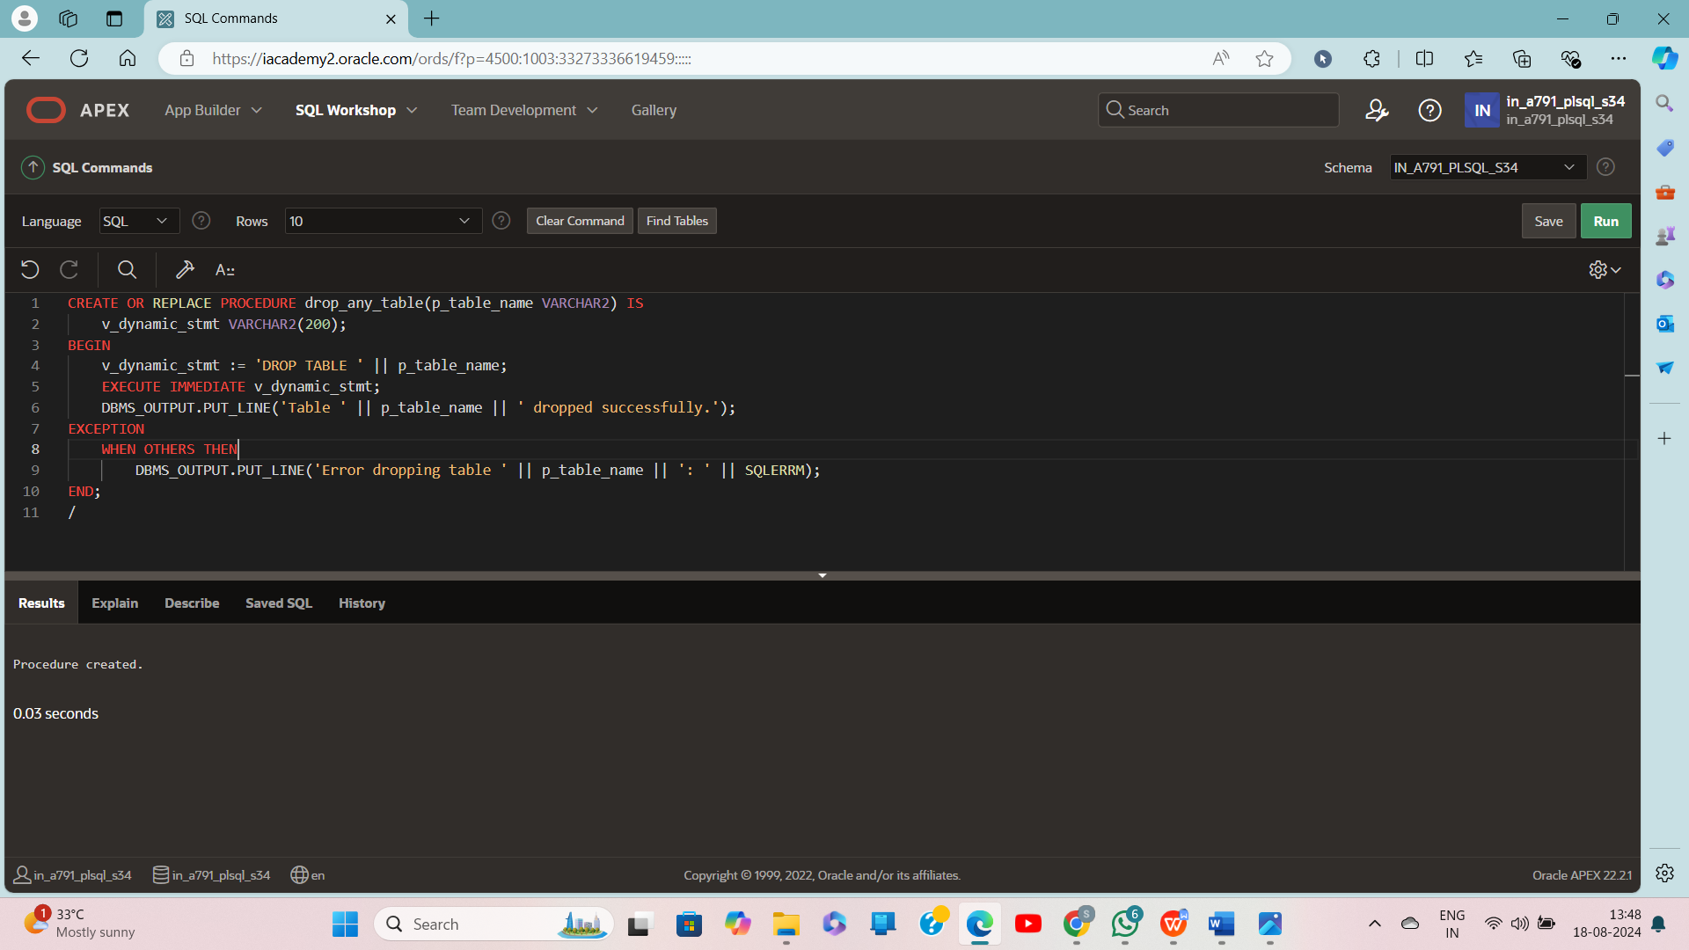

BEGIN drop_any_table('empl'); END;

